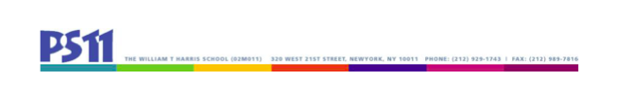

SLT Meeting
6.14.22
3:00 - 4:30

Attendance:
Principal:
Bob Bender, PS 11 Principal
Teachers:
Emma Balmuth-loris
Emily Colbert
Kim Olson
Holli Weiss (UFT Chapter Chair)
Marketa Kawa

Community Representative:
Debbie Osborne, PS 11 Programs and Community Based Organization (CBO) representative
Parents:
Inbar Aricha-Metzer
Rebecca Berkebile (Secretary)
Courtney Lewis
Reshma Saujani
Jordan Wright (Chair)
Edward So

Minutes:

I. Comprehensive Education Plan

The group analyzed available data regarding reading levels to assess appropriate goals for the CEP. The group determined that an appropriate goal was for 50% of first graders reading below the benchmark (level 1 or 2) to move up by one benchmark level.

Additional goals will be set once there are additional data.

II. Adjourn

